Team Goeieflow

Abstract

This document explains the steps that are necessary to add a new SMS Connector to Azure

INstallation SMS Connector

Azure Logic Apps

Index

Step 1: Creating a new resource 2

Step 2: Configuring the logic app 4

# Step 1: Creating a new resource

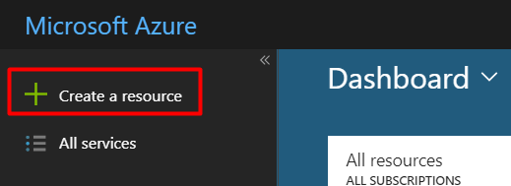

1.After you are logged in you can see left on your dashboard an option to make a new rescource, click on this.

2. Search ‘Logic apps custom connector’ and click on the result. After that click on ‘create’.

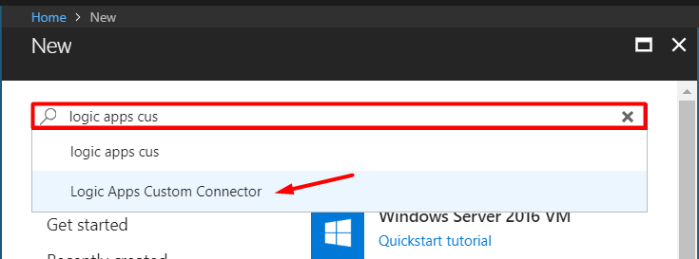

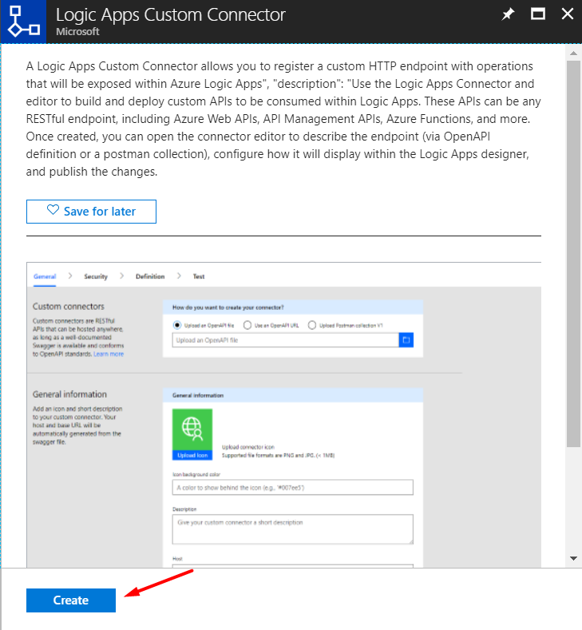

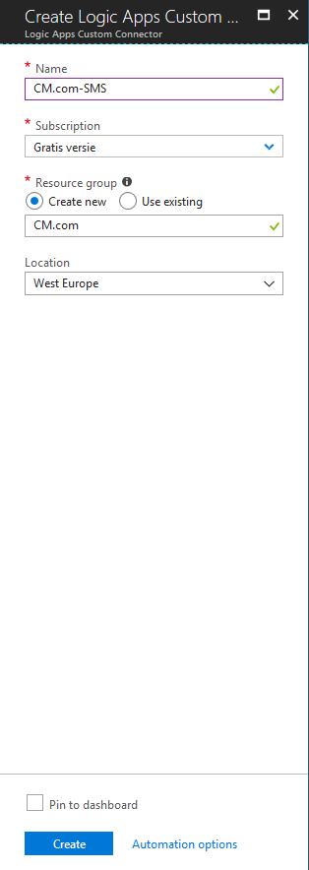3. Choose a name for your connector. After that select a type of subscription. Then choose a rescourcegroup and a location for your connector. Click on ‘create’.

# Step 2: Configuring the logic app

https://cdn.discordapp.com/attachments/359058606429175828/451678789131436050/unknown.png4. You will be sent back to the dashboard. After a while you will get a notification. Click on it.

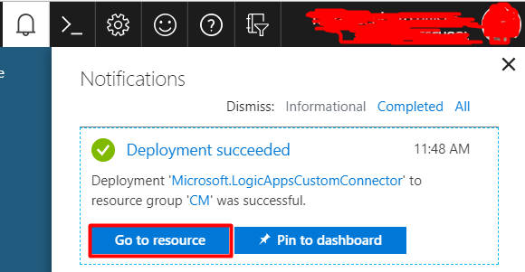5. You will see this message click on ‘Go to rescource’.

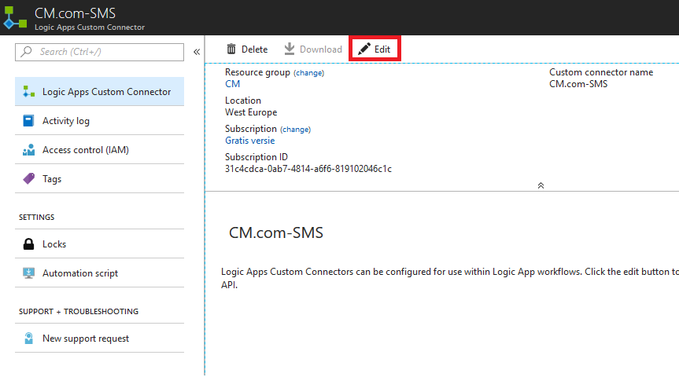6. You will see this window click on ‘Edit’.

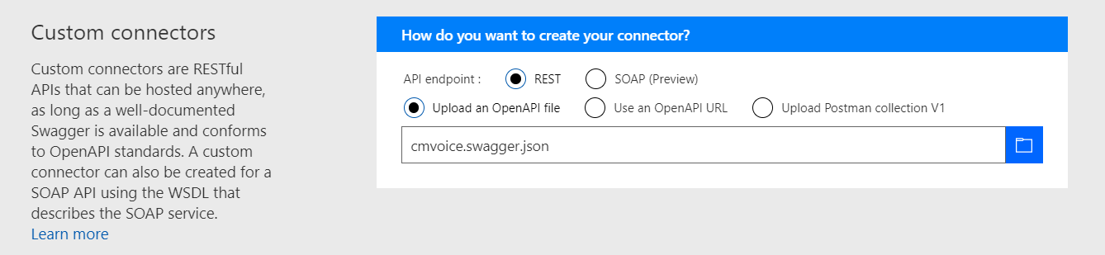7. You can ignore Custom connectors. Scroll down and go to General Information.

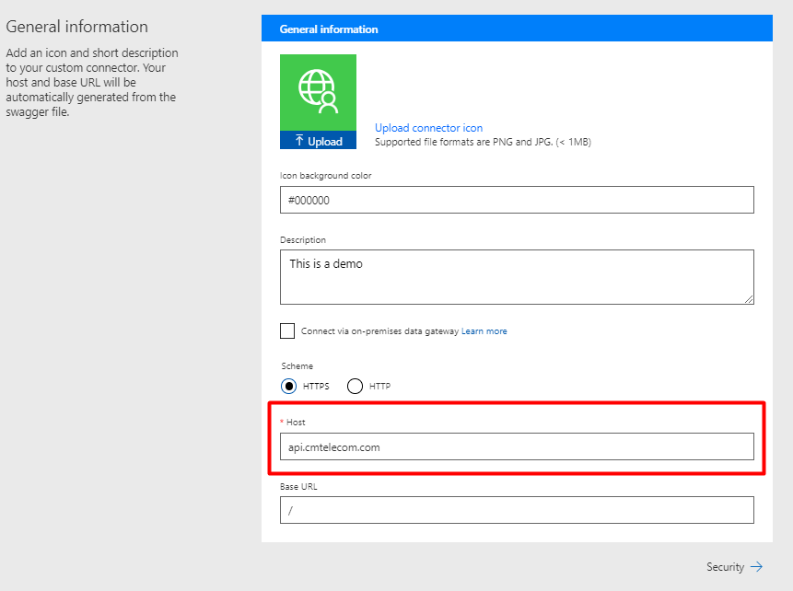8. You can add a background color and description to your liking. Leave scheme as HTTPS. But make sure you set the host field to: **api.cmtelecom.com.** Click on security when you’re done to go to the next step.

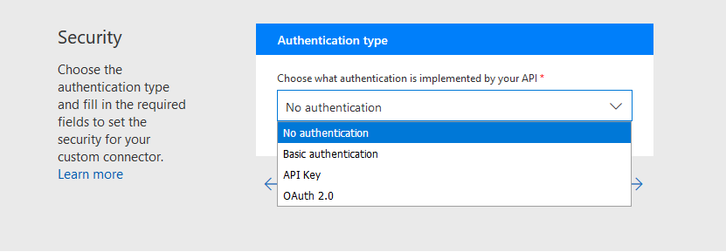9. From the first dropdown select No authentication and click on Definition.

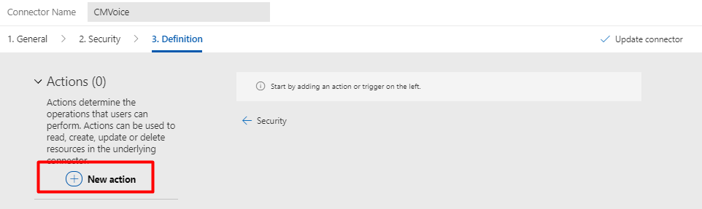10. To add a new action click on the plus sign.

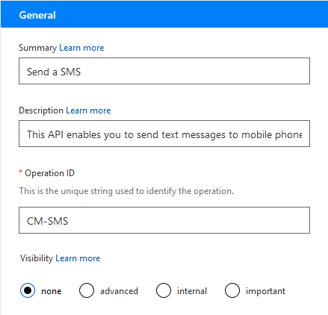

11. A form will appear, enter a summary, description a and a unique name identifier. Scroll down for the next step.

12. Under the tab general is a link with the title request. Click on ‘Import from Sample’.

13. On the right side a form will appear, select POST and enter the fields as followed separated by new line. When you’re done click ‘import’.

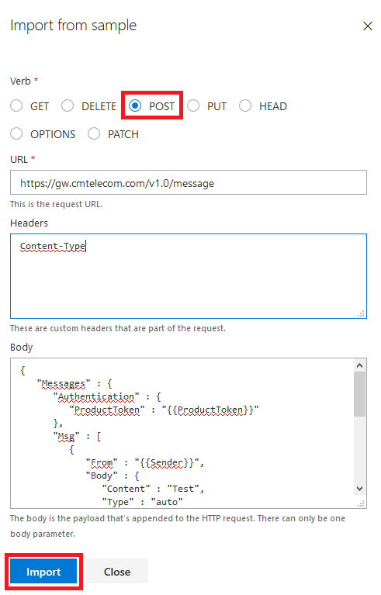**URL:**

https://gw.cmtelecom.com/v1.0/message

**Headers:**

Content-Type

**Body:**

{

"Messages" : {

"Authentication" : {

"ProductToken" : "{{ProductToken}}"

},

"Msg" : [

{

"From" : "{{Sender}}",

"Body" : {

"Content" : "Test",

"Type" : "auto"

},

"customGrouping": "{{Grouping}}",

"MinimumNumberOfMessageParts" : 1,

"MaximumNumberOfMessageParts" : 8,

"To" : [

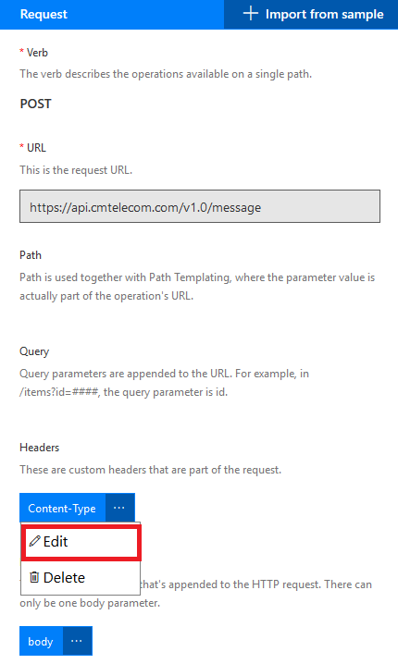 {

"Number" : "{{Recipient}}"

}

]

}

]

}

}

14. After you pressed ‘import’ you will see a form like this. Click on Content-Type and click on ‘Edit’.

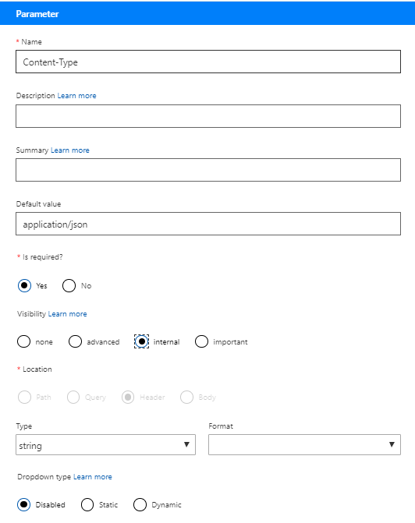15. After you clicked on ‘Edit’ you will see this form fill it in as follows:

**default data:**

application/json

**required:**

yes

**Visibility:**

Internal

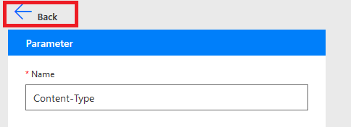

16. Click on back.

17. Click on body and click ‘Edit’.

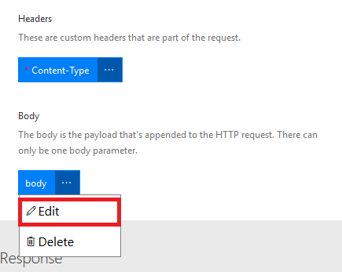

18. Set ‘Is required?’ on ‘Yes’.

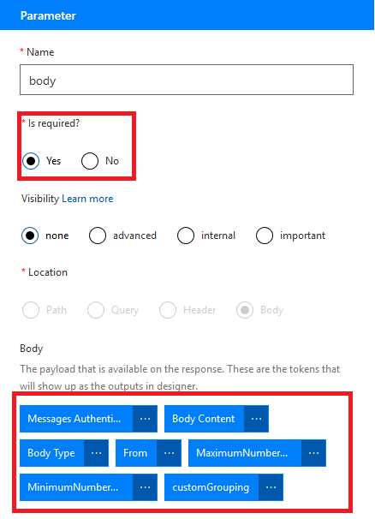

19. Set the following settings for the other parameters:

Message Authentication:

-Is required? > Yes

Body Content:

-Is required? > Yes

Body Type:

-Default value > auto

-Visibility > advanced

From:

-Is required? > Yes

-Description > Format: 0031612345678

MaximumNumberOfMessageParts:

-Default value > 8

-Visibility > advanced

MinumumNumberOfMessageParts:

-Default value > 1

-Visibility > advanced

customGrouping:

-Is required? > Yes

-Default value > Flow

-Visibility > Internal



20. Press Back until you see the General page again.

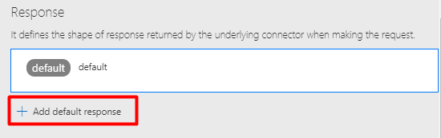

21. Scroll down and add a default response.

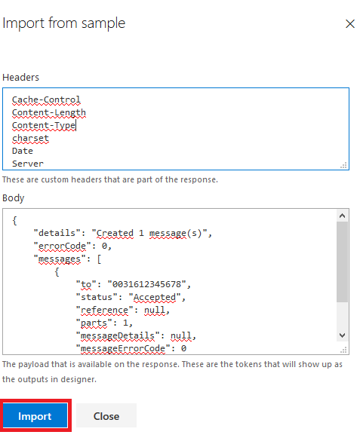22. Fill in the form as follows click on ‘import’ when you’re done.

**Headers:**

Cache-Control

Content-Length

Content-Type

charset

Date

Server

**Body:**

{

"details": "Created 1 message(s)",

"errorCode": 0,

"messages": [

{

"to": "0031612345678",

"status": "Accepted",

"reference": null,

"parts": 1,

"messageDetails": null,

"messageErrorCode": 0

}

]

}

23. When you’re done with making a response click on ‘update connector’.

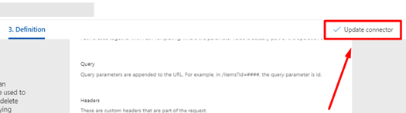

Congratulations! You are now the proud owner of your own custom SMS Connector. ☺